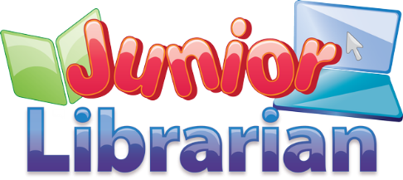
Hillcross Primary School
Book Reviews on Junior Librarian
Loading the My Reviews section
- From our school website, go to the library page and click on the Junior Librarian Link
- Type in your unique username and password
- Click on the review button. The My Reviews screen will appear
Writing your review

To find a review
- If you want to check if there is a review for a particular book, type the title in the Search box at the top right of the homepage.
- Click on the book cover to bring up the details of the book.
- Then click on the Read Review box.

